Initial Submission in myResearch for Studies Relying on an External IRB
V 04.14.20

The initial submission must include the following documentation:
- Study Information:
  - Master Consent Templates
  - Protocol
  - Other study documents as applicable

Site Information:
  - IRB FEE FORM
  - Application for Approval to Conduct Research Activities at Stony Brook University Hospital - This form is necessary to assess impact of the proposed activity on UH patients, services and facilities.
  - Inclusion/Exclusion criteria checklist - This checklist should contain required
eligibility ranges where applicable, and a line to write the subject’s actual value. Completed and maintained for each subject, along with all backup documentation (lab values, x-ray reports, confirmation of diagnosis etc.), this information will
provide definitive proof of your study subjects’ eligibility. This form must include the protocol version and date and a signature line for investigator verification.
  - Scientific Merit Review Form (non-oncology studies) - The application materials must be endorsed as scientifically meritorious by either the department chair or departmental review committee of all departments impacted by the proposed activity.
  - PRMC Approval Letter (oncology studies only) - This committee oversees and ensures the scientific merit, priorities and progress of all cancer clinical studies conducted at the Stony Brook Cancer Center.
- Request all relevant ancillary reviews (dept. chair, pharmacy, privacy, etc).
- When the Department Chair has approved of the research activity, the PI may submit for acknowledgement.
PRE-REVIEW
- Once the package is received by the Office of Research Compliance (ORC), the Reliance Administrator will conduct the internal review checks to verify the following:
- Study acceptability for reliance agreement
- Training completion by all study team members.
- Chair approval in place
- Other relevant ancillary reviews requested
- QA check of project documents
- COI disclosure completion

- After the local review is complete the submission will be moved to Pending sIRB review.
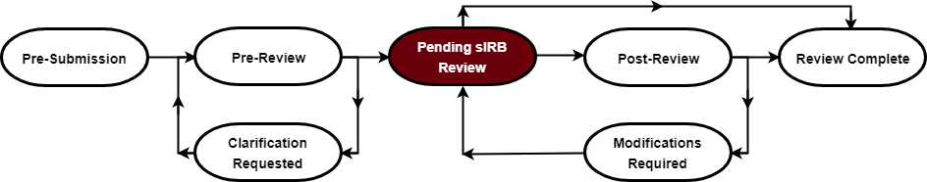

Initial Approval Granted by the External IRB
- When the External IRB has approved the project, please update the submission with the following:

Study Information
    - Update External IRB information questions 1-12 (upload approval letter in appropriate section).
    - Update other sections as applicable

Site Information
  - Attach local site approved documents

***IMPORTANT***
DO NOT ADD ANY STUDY TEAM MEMBERS WHILE SUBMISSION IS IN THE PENDING sIRB STATE.
Please send a message to the assigned IRB Coordinator for review. If documents are acceptable the project will be moved to the state of “Review Complete”
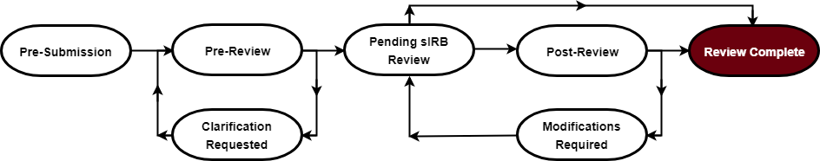

** Please be reminded that all studies approved through an External IRB must comply with Post-IRB Approval Requirements:
- Investigators approved through external IRB review must report local unanticipated problems, complaints, and any noncompliance to the ORC in addition to reporting to the external IRB. Copies of the report submitted to the external IRB are generally acceptable, but additional information may be requested on an as needed basis.

- Investigators must also submit copies of continuing review reports, updated protocols, updated consent forms, study closures and corresponding IRB approval or acknowledgment.
- Changes in PI and the addition of other research team members must be submitted to the ORC prior to the new PI or research team member assuming any study responsibilities. CITI trainings, COI review, and any other applicable requirements will be verified.
- Notices about, and reports from, DSMB’s, external monitors, auditors, or inspectors must be provided to the ORC via the IRB management system as well.
- In general, Investigators are reminded that all other University reporting requirements, such as to Compliance, Privacy, and Risk Management, remain applicable in addition to HRPP reporting requirements.

- Note: You may not proceed with any aspect of the study until:
  - all other applicable ancillary reviews have been completed.
  - the sponsor-RF contract is fully executed and the myResearch grants submission is approved by the Office of Sponsored Programs (OSP)
  - if industry sponsored, the consent form injury language has been approved by the OSP.
  - IRB approval is obtained and submitted through myResearch for final acknowledgement. The state will change to “Review Complete”

