myResearch Agreements 10.5 Training Guide

June 2023

Table of Contents
Submit an Agreement 3
Assign an Ancillary Reviewer 4
Respond to Reviewer Requests 5
Create an Amendment 6
Additional Actions 7
Workflow and Agreement States 7

Submit an Agreement

- From Dashboard, either click the Create dropdown and then the Create Agreement button or click Agreements then

Create Agreement.
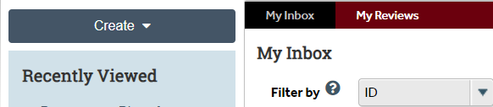
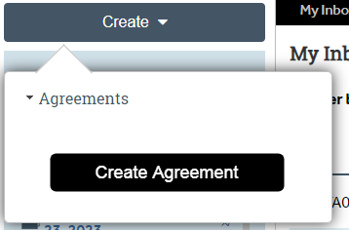

OR
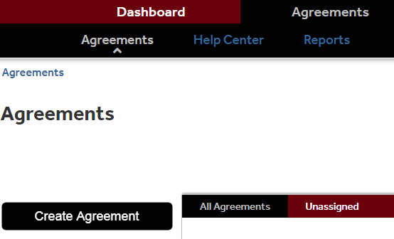

- Complete all pages. To move to the next page, click Continue. The questions marked with * are mandatory. Depending on the Agreement type you select under #5 on the first page, additional SmartForms will be generated with questions specific to the agreement type.
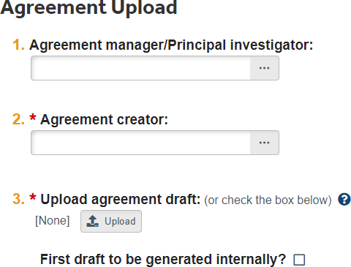
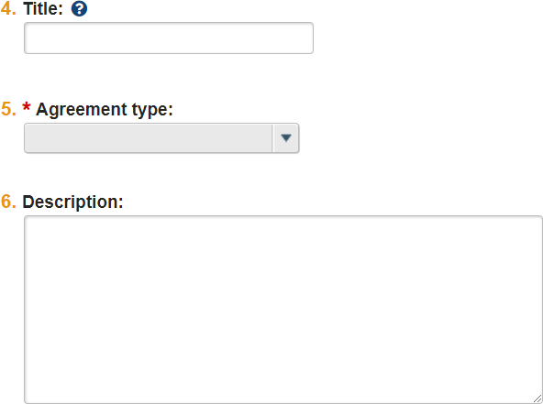
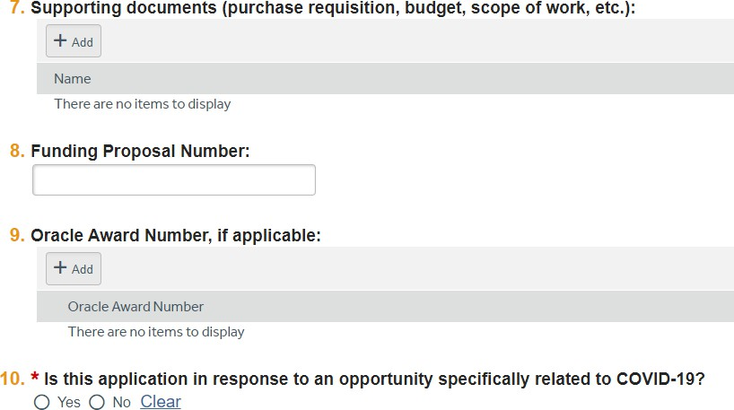
You can navigate to other pages within the SmartForms on the left hand side by selecting the applicable page.
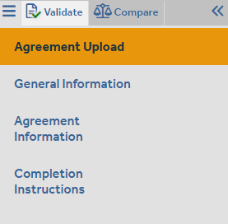

- On the last page, click Finish.
- On the left, click Submit.
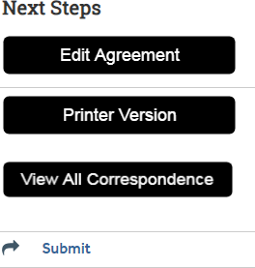

- Click OK to accept the statement and submit the agreement.
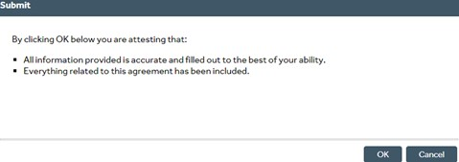

- The status will change from Pre-Submission  to Unassigned. 

Assign an Ancillary Reviewer

You can add an organization or a person as an ancillary reviewer up until you submit the agreement.

- In the top navigation, click Agreements.
- Click the All Agreements tab and then click the agreement name to open it.
- On the left, click Manage Ancillary Reviews.

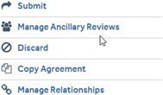

- Click Add.
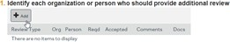

- Next to the Organization or Person, click Select and then choose the specific organization or person. Click OK.
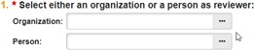
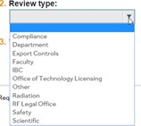
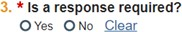

- Complete the rest of the form and click OK.
- To add more reviewers, click OK and Add Another and repeat the steps.
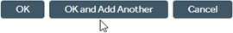
- Click OK when done.

Respond to Reviewer Requests
- From Dashboard enter My Inbox, click the agreement name to open it
- In the agreement, look for the Submit Ancillary Review activity on the left hand side and review any comments.

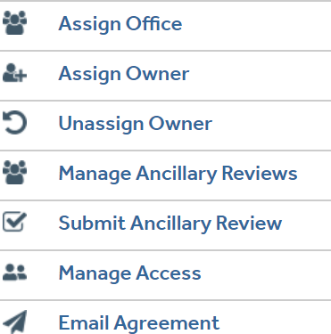

- When approving make sure to check the box indicating the Ancillary Review request you’re submitting for.
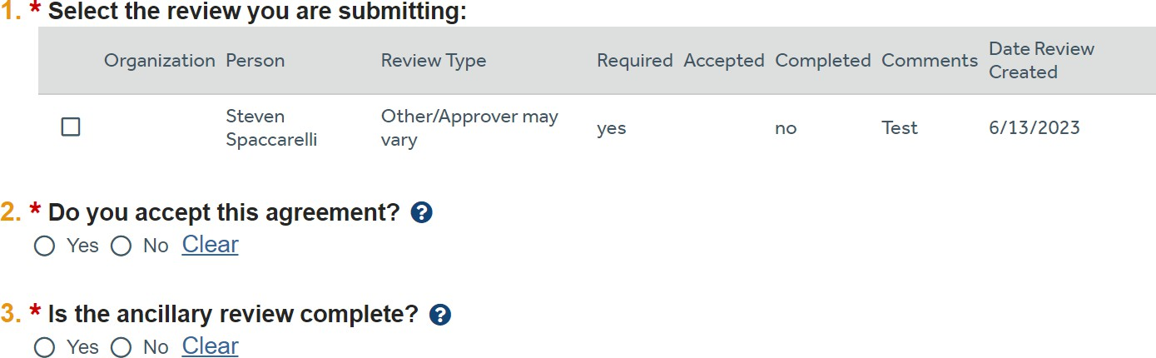

- Complete the remaining Smart Form questions and then press OK if you accept the Agreement and the Ancillary Review is completed.
- (Optional) In the Comments box, type a response to the reviewer’s comments or questions.

Create an Amendment

You can create amendments for agreements in the Active, Expired, and Evergreen states. Only one amendment can be in progress at a time for an agreement.
- In the top navigation, click Agreements.
- On the All Agreements tab, click the name of the agreement to amend.
- On the left, click Create Amendment and complete the pages.

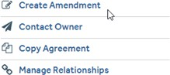

- On the last page, click Finish.
- On the left, click Submit.
- Click OK to accept the statement and submit the amendment.

Additional Actions

You can withdraw or discard agreements before they become Active.
- In the top navigation, click Agreements.
- On the All Agreements tab, click the name of the agreement to amend. Select the appropriate action which appears on the left side of the screen.
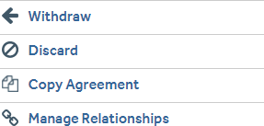

An agreement can be removed from review by clicking Withdraw or Discard. This action will discontinue the review of the agreement.
Through Manage Relationships you can link your agreement to the proposal you submit through myResearch Grants. Note: this function is not yet active in myResearch.

Workflow and Agreement States

The diagram located in the Agreements Workspace will show the state of your agreement within the Agreements workflow.
Pre-Submission: During Pre-Submission, the PI (or Agreements Manager) will create the agreement.

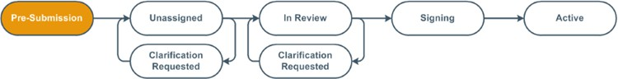


Unassigned/Clarification Requested: In the Unassigned state, the agreement has been submitted and is reviewed by the Office of Sponsored Programs, who can send the agreement back to the study team for more information or clarifications if needed. The agreement will be assigned to an Agreements Reviewer who is a Grants of Contracts Administrator in OSP.

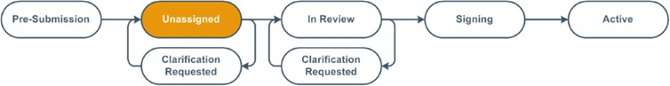



In Review / Clarification Requested: The Agreements Reviewer completes a thorough review of the agreement, and can send the agreement back to the study team for more information or clarifications if needed.
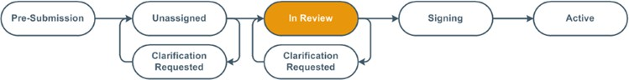


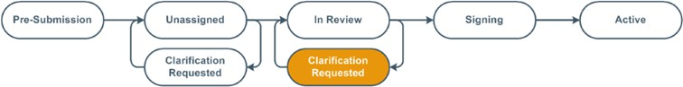
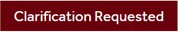

Signing: During Signing, the agreement is routed for internal and external signatures. Once that is complete, the agreement is activated.
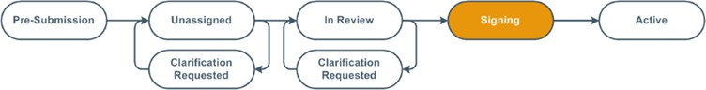

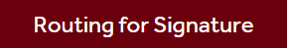

Active: The submission will reach its final determination, Active, after the final signed copy has been uploaded to the system.
