Computer Engineering Curriculum Map (Fall 2020 or later)
Junior
Sophomore
Freshman

Computer Engineering Curriculum Map (Fall 2020 or later)
Freshman |  | 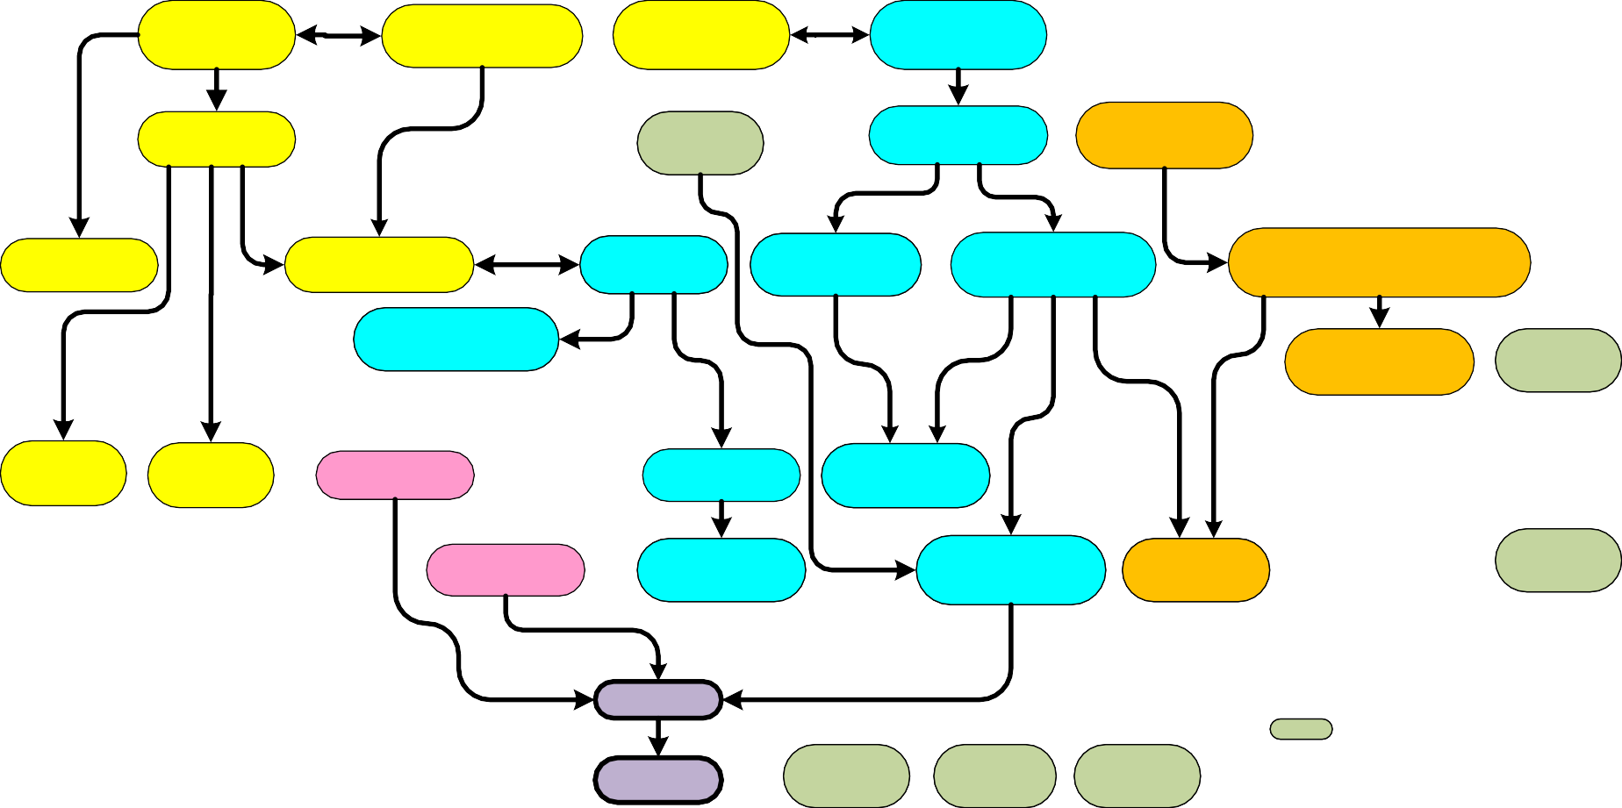  AMS 151  Calculus I  AMS 161  Calculus II | PHY 131/133  Physics I | ESE122  Disc. Math  WRT 102 | ESE123  Intro. to ECE  ESE118  Digital Logic |  | Math & Science  Core Engineering  Electives  ESE124 Software  Prog. Fund.  Senior Design Project
Sophomore | AMS210  Linear Algebra | PHY 132/134  Physics II  ESE272  Electronics |  | ESE271  Circuits | ESE382  VHDL | ESE280 ESE224  _{Embedded} _{Micro.} Adv. Prog. & Data Struc.  ESE 344 HUM  Software Tech.
Junior | AMS261 | AMS361 Elective*  Calculus IV  Elective* Elective* |  | ESE 305 | ESE345
Junior | Calculus III |  |  | Sig. Sys. | Comp. Arch.
Junior |  |  |  | ESE306 |  | ESE300 ESE333 SBS
Junior |  |  |  | Random Sig. Sys. |  | Tech. Comm. Real Time OS
Senior | Elective*  Elective* | Elective*  Elective* ESE 301  Eng. Ethics |  | ESE440 ESE441 | Arts | Math or Science Elective  SBC (Gen. Edu.)  USA GLO Engineering Ethics

Notes:
Senior
Courses in bold face require a grade of C or higher.
One of the SBC courses should also have DIV designation.
* Seven upper-level ESE courses (excluding those already required) with a minimum of five chosen from the following:
ESE 326, ESE 327, ESE 343, ESE 346, ESE 355, ESE 356, ESE 358, ESE 360, ESE 366, ESE 375, ESE 381, ESE 388, ESE 457, ESE 481

