@wolfiewriters

SPRING

WE D N E S D A Y S
Melville N3045 “Fishbowl” 12:30-1:30 PM
2025

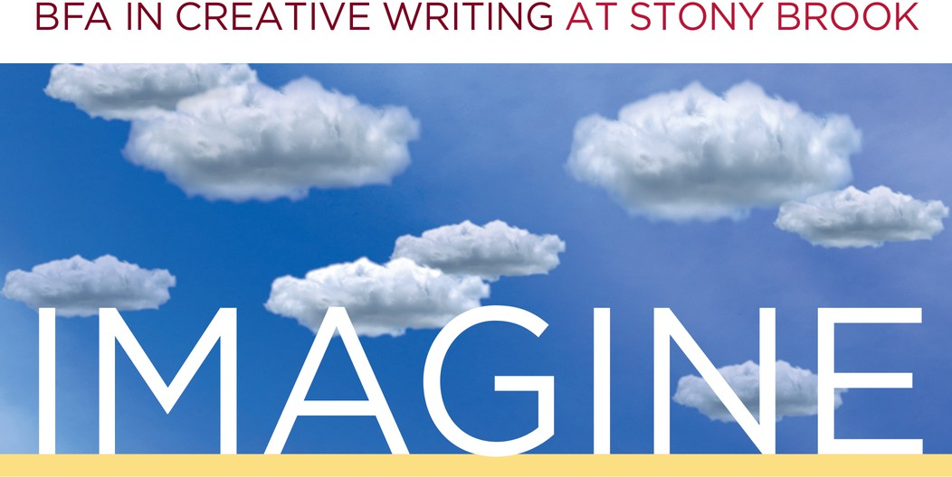

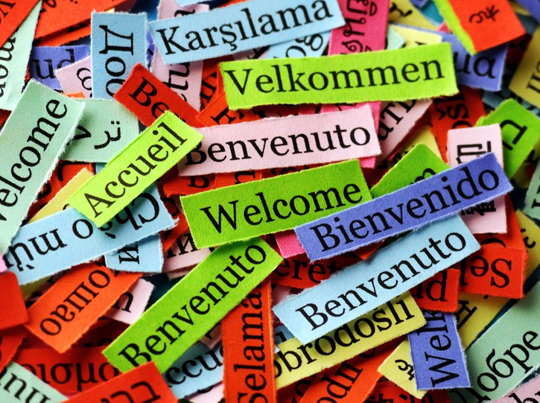
FEB. 26 ~ Welcome Mixer with Mira Johnson
New and returning students gather in Melville N3045 “Fishbowl” to kick off the new term with inspiring word games, new friends, and yummy pizza!

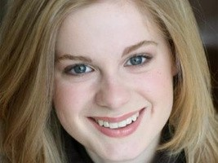
APR. 2 ~ Faculty Reading + Q&A with Marissa Levien
Marissa Levien is a writer and artist living in New York. Her debut novel The World Gives Way was a finalist for the Bradbury Award and was named one of the Best Sci Fi Books of 2021 by the New York Times.

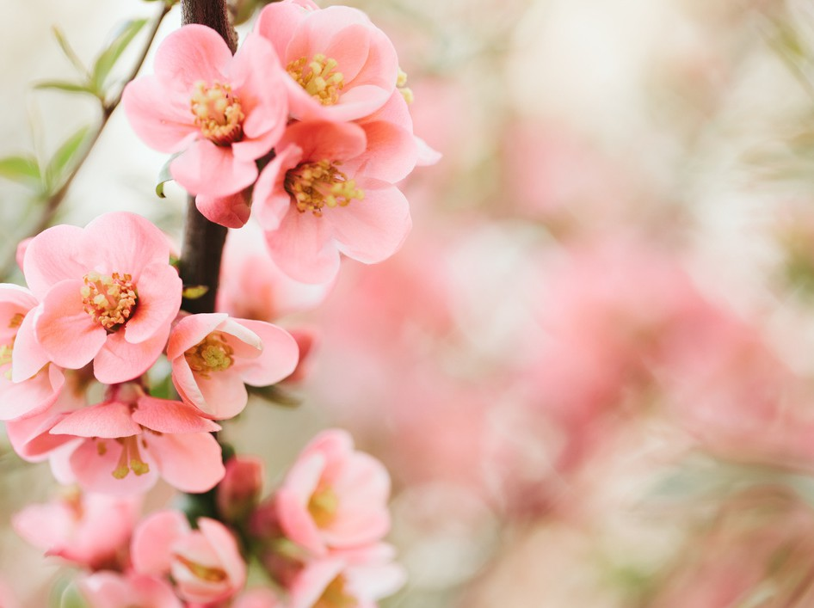
APR. 17 ~ Shirley Strum Kenny Arts Festival
April is for the Arts! Come join us for a springtime smorgasbord of student creativity. Featuring readings, screenings, live music, and more!


APR. 30 ~ Undergraduate Student Showcase
Undergraduate writers, it's your time to shine! Democratically nominated writers will have the chance to share their work with their peers in a public reading. Family and friends are welcome. Refreshments served!

To request accommodations or more information, please email cwlundergrad@stonybrook.edu

