FALL
WEDNESDAYS
We've Gone Virtual!!

2020

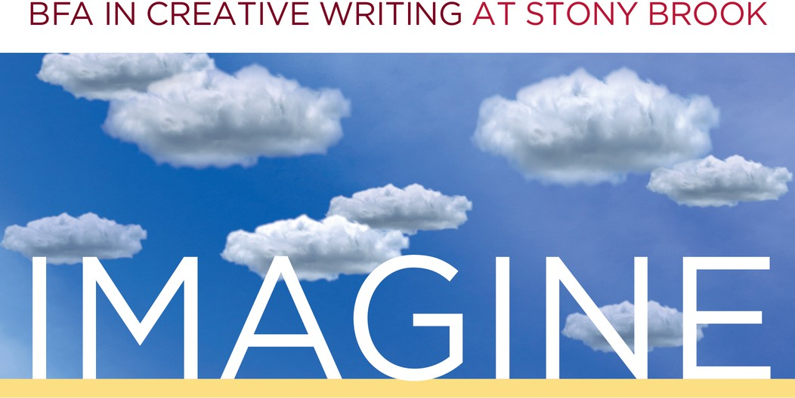


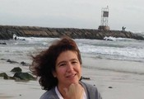



Sept. 16 ~ How to Major in Creative Writing Learn how to apply, connect with current majors, and persuade your parents that you haven't lost
your m. RSVP Here


Sept. 30 ~ Life After Stony Brook

Juniors, Seniors, let's talk through graduate school options with a panel of faculty. Join us on Zoom!
Oct. 14 ~ Faculty TA Reading
Find out what your professors are writing.. Join us on YouTube!
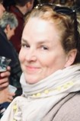
Nov. 4 ~ New Faculty Reading
Welcome new faculty members poet Miranda Beeson and polyglot Molly Gaudry.
Join us on YouTube!

Dec. 9 ~ Student Showcase Undergraduate writers, it's your turn to shine! Join us on YouTube!
To request accommodations or for more information, contact cwlundergrad@stonybrook.edu

