FALL
WEDNESDAYS
Melville N3045 1-2:20PM

2021

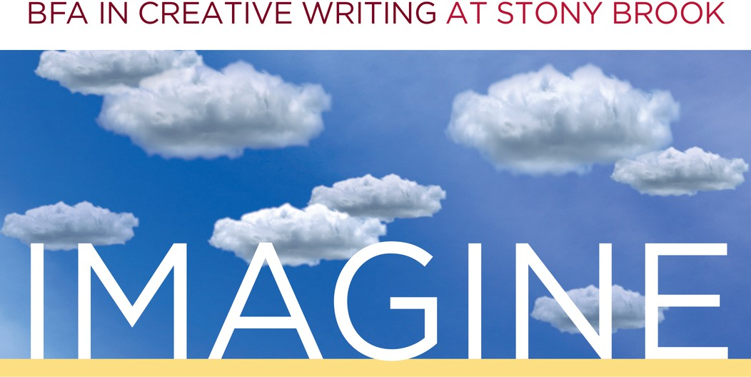

Sept.1 ~ Fall Kick-Off/Welcome Back

Welcome Back!
Welcome back, BFA majors and minors, and welcome, newly admitted students! Join us for pizza and refreshments, socializing, and some optional writing games! See you there!


Sep. 29 ~ TA Reading
Find out what your professors are writing.

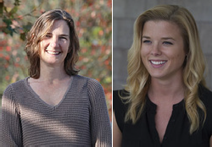
Oct. 27 ~ Faculty Reading
Featuring Julie Sheehan (outgoing Director of the BFA) and Genevieve Sly Crane (incoming Director of the BFA)!

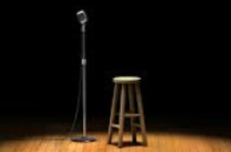
Dec. 1 ~ Student Showcase
Undergraduate writers, it's your turn to shine!

