

ADVANCED ENERGY CONFERENCE 2026

Adapting the Course: Innovation for a New Energy Era

SPONSOR AEC 2026
Sponsoring AEC 2026 showcases your organization’s leadership in the clean
energy transition, aligning your brand with innovation, sustainability, and the industry’s top decision-makers driving real-world impact.
It’s more than visibility; it’s a statement that your organization is leading the way toward a cleaner energy future.

BENEFITS OF SPONSORSHIP
Global Exposure – Connect with top energy leaders from around the world Premier Exhibit Space – Stand out in a high-traffic, strategic location
Targeted Engagement – Network with key decision-makers through curated opportunities Media Visibility – Boost your profile across press and social channels
Brand Placement – Showcase your logo in conference materials and marketing Full Access – Attend all sessions, panels, and the exhibit hall
Recognition – Be featured in opening remarks and official program

For sponsorship opportunities, please contact:
Email: kathleen.ferrell@stonybrook.edu Phone: (631) 871-8451


Passes
PLATINUM - $100,000
- 12 VIP Full Two-Day Conference Passes
- 10 VIP Sponsor’s Show Floor Only Passes
- 4 VIP Exhibit Full Attendee Passes
- Host meetings in the breakout rooms during the first day of the conference
- Reserved VIP table for 10 during lunch
- Speaking Opportunities: Keynote or plenary session presentations

Business Development/Exhibition
- Recognition of sponsorship in opening remarks welcome letter and on all AEC signage
- Premium 20-foot-wide booth exhibit and placement of two promotional items
(furnished by sponsor) in attendee tote bag
GOLD - $70,000

Passes
- 8 VIP Full Two-Day Conference Passes
- 10 VIP Sponsor’s Show Floor Only Passes
- 2 VIP Exhibit Full Attendee Passes
- Host meetings/roundtables on the first day reserved VIP table for 10 during lunch
- Participation in panel discussions or breakout sessions

Business Development/Exhibition
- Recognition of sponsorship in welcome letter and on all AEC signage
- Preferential 10-foot-wide booth exhibit and placement of one promotional item (furnished by sponsor) in attendee tote bag
SILVER- $50,000

Passes
- 6 VIP Full Two-Day Conference Passes
- 10 VIP Sponsor’s Show Floor Only Passes
- 2 VIP Exhibit Full Attendee Passes
- Reserved VIP table for five during lunch
- Participation in panel discussions

Business Development/Exhibition
- Recognition of company sponsorship on signage
- 10-foot-wide booth exhibit

Brand Exposure
- Logo placement and brand presence featured in conference program and on signage, banners and conference website
- Welcome from sponsor representative in the program and 150-word company profile featured in the program and on the website

Media
- Preferential press conference positioning and mention of sponsorship in press releases and social media
- Three (3) Blog stories written featuring sponsor and placed on website and Social Media
- Weekly Social Media exposure

Brand Exposure
- Logo placement and brand presence featured in the program and on signage, banners and website
- 120-word company profile featured in the conference program and on the website

Media
- Mention of sponsorship in press releases
- One (1) Blog story written featuring sponsor and placed on website and Social Media
- Weekly Social Media exposure

Brand Exposure
- Logo placement in program, signage and conference website
- 100-word company profile

Media
- BiWeekly Social Media exposure



Passes
BRONZE - $30,000
  - 4 VIP Full Two-Day Conference Passes
  - 8 VIP Sponsor’s Show Floor Only Passes
  - 2 VIP Exhibit Full Attendee

Business Development/Exhibition
  - Recognition of company sponsorship on signage
  - 10-foot-wide booth exhibit

Brand Exposure
  - Logo placement in program, signage and conference website with 80-word company profile

Media
  - Bimonthly Social Media exposure (2x monthly)

Passes
GREEN SPONSOR - $20,000
    - 3 VIP Full Two-Day Conference Passes
    - 5 VIP Sponsor’s Show Floor Only Passes
    - 2 VIP Exhibit Full Attendee

Business Development/Exhibition
    - Recognition of company sponsorship on signage
    - 10-foot-wide booth exhibit
SUPPORTER/EXHIBITOR - $15,000

Brand Exposure
- Logo placement in program, signage and conference website with 65-word company profile

Media
- Bimonthly Social Media exposure (2x monthly)

Passes
  - 2 VIP Full Two-Day Conference Passes
  - 3 VIP Sponsor’s Show Floor Only Passes
  - 2 VIP Exhibit Full Attendee Passes

Business Development/Exhibition
  - Recognition of company sponsorship on signage
  - 10-foot-wide booth exhibit
CO-SPONSOR/EXHIBITOR - $10,000

Passes
  - 1 VIP Full Two-Day Conference Passes
  - 2 VIP Exhibit Full Attendee Passes

Business Development/Exhibition
  - Recognition of company sponsorship on signage

Brand Exposure
- Logo placement in program, signage and conference website with 50-word company profile

Media
- Monthly Social Media exposure

Passes
6’ Exhibit Table - $6,000
  - 2 VIP Exhibit Full Attendee Passes

Business Development/Exhibition
  - One six (6) foot table with chair

Brand Exposure
- Logo placement in exhibitor guide and company listed on show floor brochure

Passes
START-UP INCUBATOR CORRAL - $TBD
  - 1 VIP Exhibit Full Attendee Passes

Business Development/Exhibition
  - One six (6) foot table with chair

Brand Exposure
- Logo placement in exhibitor guide and company listed on show floor brochure

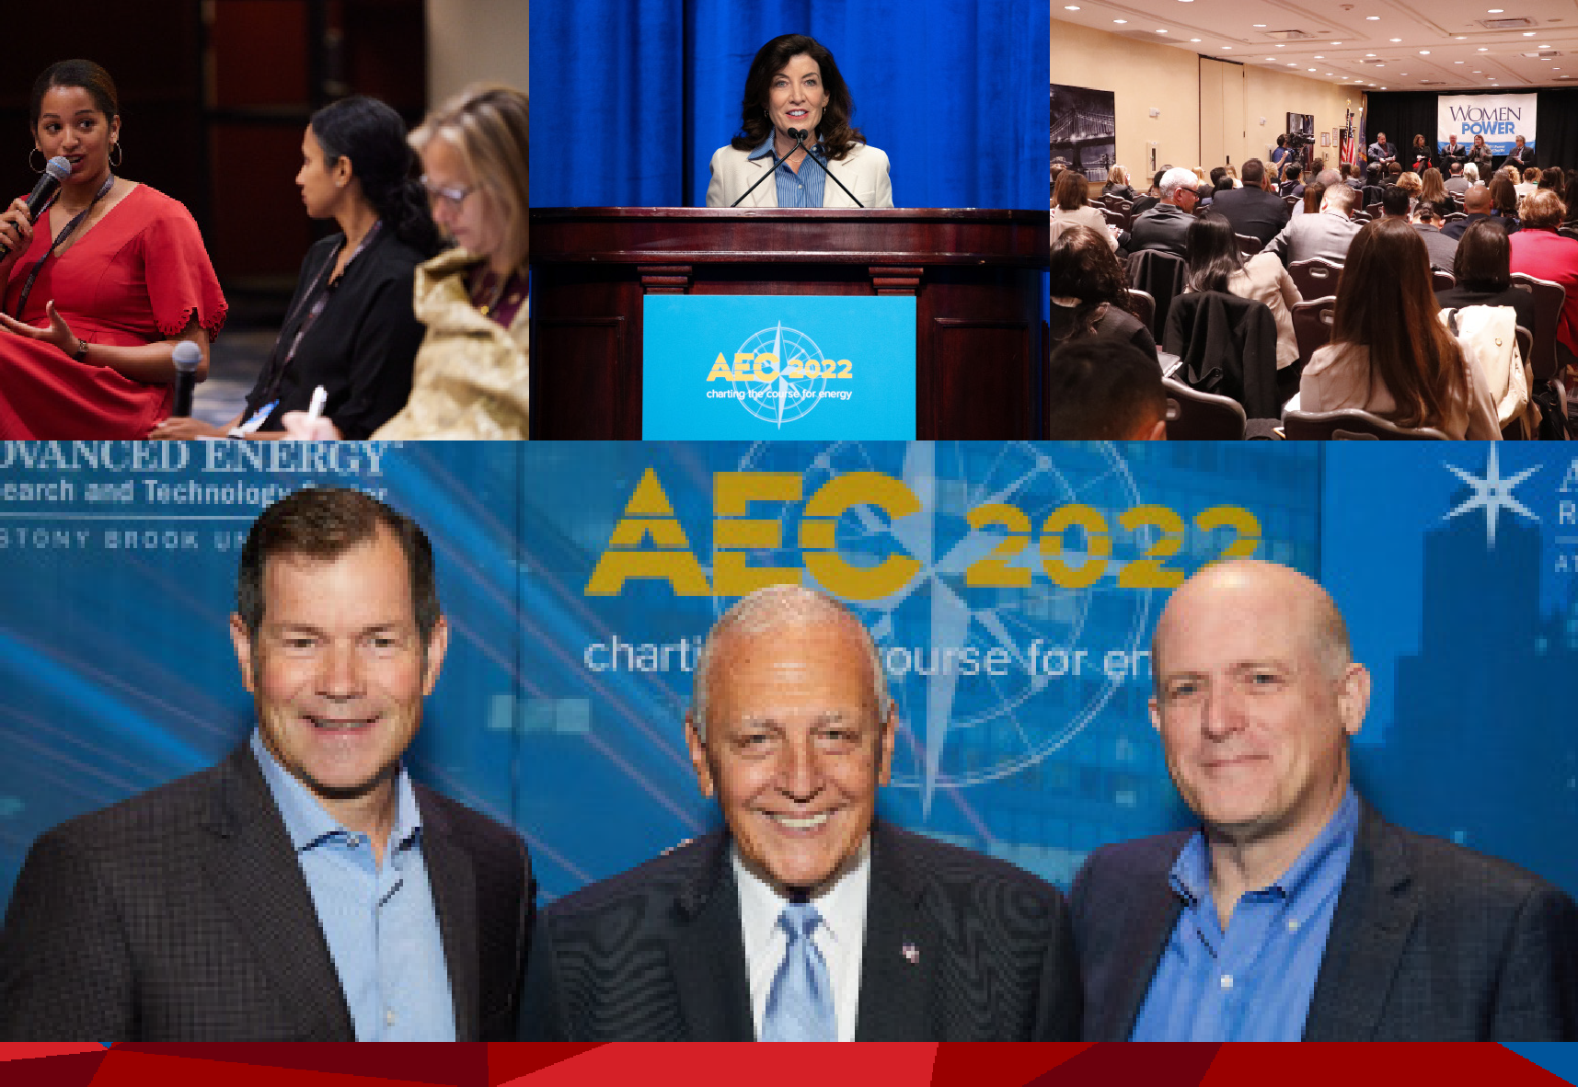

Stony Brook University/SUNY is an affirmative action/equal opportunity educator and employer. This document is available in alternative format

